**Запрос на кафедру и институт Пенкина**

WITH summary AS (SELECT

emp.[Id] 'EmployeeID'

,[FirstName]

,[MiddleName]

,[LastName]

,[Iin]

,[DateOfBirth]

,[IsMale]

,ord.[DateIssued] 'LastOrder DateIssued'

,ord.TypeId

,pos.[Id] 'PositionId'

,ROW_NUMBER() OVER (PARTITION BY emp.[Id] ORDER BY ord.[DateIssued] DESC) AS rk

FROM [kaznitu_hr].[dbo].[Orders] ord

LEFT OUTER JOIN

[kaznitu_hr].[dbo].[OrderEmployees] ordEmp

ON (ord.Id = ordEmp.OrderId)

LEFT OUTER JOIN

[kaznitu_hr].[dbo].[Employees] emp

ON (emp.Id = ordEmp.EmployeeId)

LEFT OUTER JOIN [kaznitu_hr].[dbo].[SimpleDictionaries] dict

ON (dict.Id = ord.TypeId)

LEFT OUTER JOIN [kaznitu_hr].[dbo].[Positions] pos

ON (ordEmp.PositionId = pos.Id)

)

SELECT

s.*

,dPrnt.Title 'Cafedra'

,dep.Title 'Institute'

FROM summary s

LEFT OUTER JOIN

[kaznitu_hr].[dbo].[DepartmentPositions] dp

ON

dp.PositionId = s.PositionId

LEFT OUTER JOIN

[kaznitu_hr].[dbo].[Departments] dPrnt

ON

dPrnt.Id = dp.DepartmentId

LEFT OUTER JOIN

[kaznitu_hr].[dbo].[Departments] dep

ON

dep.Id = dPrnt.ParentId

WHERE

s.rk = 1

AND

EmployeeID

IN

(/*19285, 25896,*/ 23794)

AND

(dPrnt.ParentId = 213

OR

dPrnt.ParentId IS NULL)

ORDER BY Institute

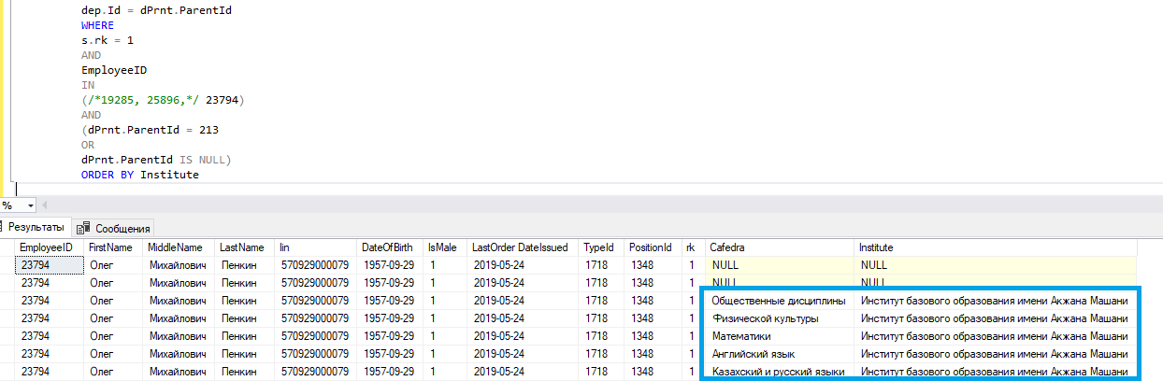

Приказы на Пенкина. Институт имеется, кафедра заполнена.

**Запрос на кафедру и институт Бимановой**

WITH summary AS (SELECT

emp.[Id] 'EmployeeID'

,[FirstName]

,[MiddleName]

,[LastName]

,[Iin]

,[DateOfBirth]

,[IsMale]

,ord.[DateIssued] 'LastOrder DateIssued'

,ord.TypeId

,pos.[Id] 'PositionId'

,ROW_NUMBER() OVER (PARTITION BY emp.[Id] ORDER BY ord.[DateIssued] DESC) AS rk

FROM [kaznitu_hr].[dbo].[Orders] ord

LEFT OUTER JOIN

[kaznitu_hr].[dbo].[OrderEmployees] ordEmp

ON (ord.Id = ordEmp.OrderId)

LEFT OUTER JOIN

[kaznitu_hr].[dbo].[Employees] emp

ON (emp.Id = ordEmp.EmployeeId)

LEFT OUTER JOIN [kaznitu_hr].[dbo].[SimpleDictionaries] dict

ON (dict.Id = ord.TypeId)

LEFT OUTER JOIN [kaznitu_hr].[dbo].[Positions] pos

ON (ordEmp.PositionId = pos.Id)

)

SELECT

s.*

,dPrnt.Title 'Cafedra'

,dep.Title 'Institute'

FROM summary s

LEFT OUTER JOIN

[kaznitu_hr].[dbo].[DepartmentPositions] dp

ON

dp.PositionId = s.PositionId

LEFT OUTER JOIN

[kaznitu_hr].[dbo].[Departments] dPrnt

ON

dPrnt.Id = dp.DepartmentId

LEFT OUTER JOIN

[kaznitu_hr].[dbo].[Departments] dep

ON

dep.Id = dPrnt.ParentId

WHERE

s.rk = 1

AND

EmployeeID

IN

(/*19285, 23794,*/ 25896)

AND

(dPrnt.ParentId = 213

OR

dPrnt.ParentId IS NULL)

ORDER BY Institute

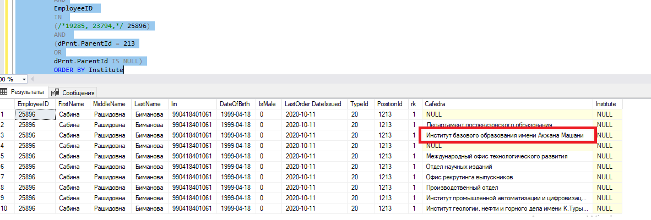

Приказы на Биманову, Институт пустует, кроме того, записан на месте кафедры

**Запрос на кафедру и институт Конакбаевой**

WITH summary AS (SELECT

emp.[Id] 'EmployeeID'

,[FirstName]

,[MiddleName]

,[LastName]

,[Iin]

,[DateOfBirth]

,[IsMale]

,ord.[DateIssued] 'LastOrder DateIssued'

,ord.TypeId

,pos.[Id] 'PositionId'

,ROW_NUMBER() OVER (PARTITION BY emp.[Id] ORDER BY ord.[DateIssued] DESC) AS rk

FROM [kaznitu_hr].[dbo].[Orders] ord

LEFT OUTER JOIN

[kaznitu_hr].[dbo].[OrderEmployees] ordEmp

ON (ord.Id = ordEmp.OrderId)

LEFT OUTER JOIN

[kaznitu_hr].[dbo].[Employees] emp

ON (emp.Id = ordEmp.EmployeeId)

LEFT OUTER JOIN [kaznitu_hr].[dbo].[SimpleDictionaries] dict

ON (dict.Id = ord.TypeId)

LEFT OUTER JOIN [kaznitu_hr].[dbo].[Positions] pos

ON (ordEmp.PositionId = pos.Id)

)

SELECT

s.*

,dPrnt.Title 'Cafedra'

,dep.Title 'Institute'

FROM summary s

LEFT OUTER JOIN

[kaznitu_hr].[dbo].[DepartmentPositions] dp

ON

dp.PositionId = s.PositionId

LEFT OUTER JOIN

[kaznitu_hr].[dbo].[Departments] dPrnt

ON

dPrnt.Id = dp.DepartmentId

LEFT OUTER JOIN

[kaznitu_hr].[dbo].[Departments] dep

ON

dep.Id = dPrnt.ParentId

WHERE

s.rk = 1

AND

EmployeeID

IN

(/*25896, 23794,*/ 19285)

AND

(dPrnt.ParentId = 213

OR

dPrnt.ParentId IS NULL)

ORDER BY Institute

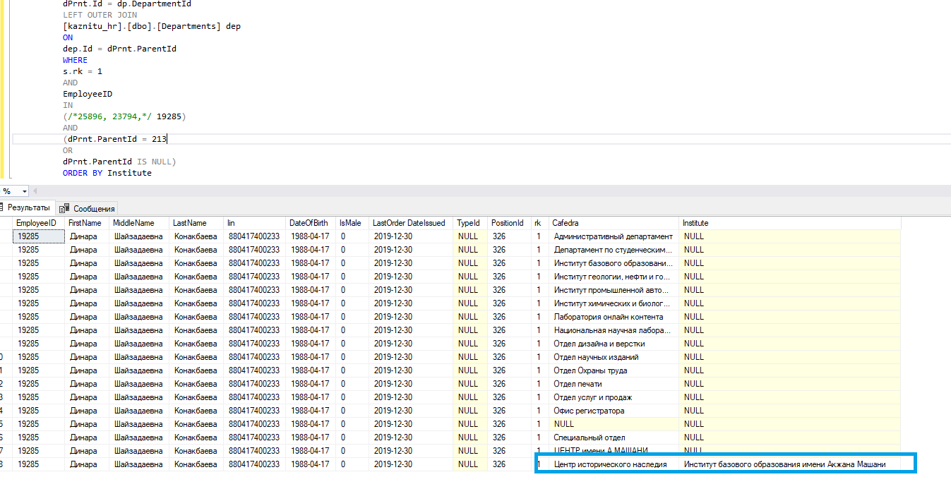

Приказы на Конакбаеву. Институт имеется, кафедра заполнена